

**USER MANUAL**

**Copyright © 2016 by e-brgy: : Generic Web-based Barangay Resident Monitoring and Request Management System Project Team**

**e-brgy: Generic Web-based Barangay Resident Monitoring and Request Management System** is a registered trademark used herein under license. *All rights reserved*. This document is protected by copyright. No part of it may be produced, stored in retrieval system, or transmitted, in any form or by any means – graphic, electronic, or mechanical, including photocopying, recording, or otherwise—without prior written permission of the copyright law. This user manual is not for sale. For permission requests, write to the publisher, addressed “Attention: Permissions Coordinator,” at the address below.



PUP A. Mabini Campus, Anonas St., Sta. Mesa

Manila, Philippines 1016



**Co-Ownership**

POLYTECHNIC UNIVERSITY OF THE PHILIPPINES

PUP A. Mabini Campus, Anonas St., Sta. Mesa

Manila, Philippines 1016

**Software Developers:**

Jomari G. Ramos

Paulo S. Samson

Jessa S. Belleza

Ma. Kristina V. Tiamsic

Mark S. Porcalla

**License Agreement**

**IMPORTANT--READ THESE TERMS CAREFULLY BEFORE INSTALLING THIS SOFTWARE. BY USING THIS SOFTWARE, YOU ACKNOWLEDGE THAT YOU HAVE READ THIS LICENSE AGREEMENT, THAT YOU UNDERSTAND IT, AND THAT YOU AGREE TO BE BOUND BY ITS TERMS.**

**Recitals**

Use of e-brgy Software requires the use of the software itself, a server (for publishing over the internet), third party softwares; apache server(for intranet use like xampp or wampp), composer, LARAVEL php framework support, and a computer sys­tem. The SOFTWARE is protected by copyright laws and international copyright treaties, as well as other intellectual property laws and treaties. The SOFTWARE is not sold, and

instead is only licensed for Your use, strictly in accordance with this Agreement. Other third party softwares are bounded by their own license agreement therefore the use of these third-party software are not included in these license agreement and any distribu­tion and merchandising is not allowed by the project team for the reason of legal terms.

This Agreement sets forth the terms and conditions of the SOFTWARE only.

**Grant of License**

Rights and Limitations of the Grant

Provided that Licensee complies with the terms of this Agreement, e-brgy PROJECT TEAM hereby grants Licensee the following limited, non-exclusive, non-transferable, non-sub licensable right to use the SOFTWARE, with the following limitations:

**Redistribution Rights**

Anyone provided by the e-brgy PROJECT TEAM a copy of the software does not have the right in neither to distribute the software in any terms or merchandise. Anyone who is provided with a copy of a non-owner is not bounded by the license grant to use the software and may be subjected to legal terms. Only developers, co-owner POLY­TECHNIC UNIVERSITY OF THE PHILIPPINES and people who are bounded by under the service and management of the UNIVERSITY can distribute the SOFTWARE.

**Ownership and Limitations**

e-brgy PROJECT TEAM agrees to label any physical copy of the Software with the following statement: "Copyright **©** 2016|**PUP BSIT**| All rights reserved.”.

e-brgy PROJECT TEAM agrees not to attempt to remove the internal copyright notices or user identification.

e-brgy PROJECT TEAM agrees not to modify the Source Code (other than changing path statements) or to use the source code to build another software system, whether for internal use or to market as a software system.

e-brgy PROJECT TEAM agrees not to reverse engineer the Software for internal use or to market a software system using the algorithms contained in the Source Code.

**Termination**

e-brgy PROJECT TEAM may terminate the license if the licensed organization violates this Agreement. e-brgy PROJECT TEAM agrees to cease use of the Software upon termination and remove, uninstall, and delete all copies of the Software from its computer systems.

**Warranty**

e-brgy PROJECT TEAM warrants that the Software will perform as specified in the user manual. If the Software does not perform as specified, e-brgy PROJECT TEAM will make reasonable efforts to cause the Software to perform as specified in the agreement, at its own expense.

**DISCLAIMER**

THIS SYSTEM AND DOCUMENT HAS BEEN MADE BYe-brgy PROJECT TEAM FOR GUIDE PURPOSE FOR THE **e-brgy: Generic Web-based Barangay Resident Monitoring and Request Management System** IS NOT FOR SALE. THE SOFTWARE AND ACCOMPA­NYING DOCUMENTATION, IF ANY, PROVIDED HEREUNDER IS PROVIDED "AS IS". REGENTS HAS OBLIGATION TO PROVIDE MAINTENANCE, SUPPORT, UPDATES, ENHANCEMENTS, OR MODIFICATIONS.

**Preface**

This USER MANUAL is intended for the e-brgy PROJECT TEAM that produced a system named **e-brgy: Generic Web-based Barangay Resident Monitoring and Request Management System.** This software system aims to help ease and fasten the works in the barangay by monitoring its requests for documents, items and facilities. Also by having an accurate information about residents, household and officials within the barangay. The goal of this manual is to give a broad overview of the system’s purpose, developer’s objectives and its software requirements. Also this manual includes how to operate the system from logging in as an admin or barangay official, creating and managing the users, updating details about a resident, item, facility, or document and how to use system’s specific functions and view previously made transactions. The manual consists of troubleshooting and contacts of the developers in case of an unwanted messages or system inaccuracy appear while handling the system.

**Table of Contents**

Copyright Information i

End-User License Agreement ii

Preface iv

Contents v

Chapter I: Introduction1

Background Details1

Objective1

Document and System Convention1

System Requirements2

Contact Us3

Chapter 2 Software Installation4

Installation of third party softwares4

e-brgy software5

**Chapter 3: Software Setup*6***

Intranet Implementation 6

Internet Implementation 6

**Chapter 4: Software Basic*7***

Start-up7

User Profile 7

Log-out 7

**Chapter 5: Using the Software*9***

Maintenance9

Transaction 17

Queries 26

Reports27

Utilities 28

**Chapter 5: Troubleshooting*31***

**Chapter I**

**Introduction**

**Background Details**

**e-brgy** is a generic web-based barangay resident monitoring and request management system. It aims to help ease and fasten the works in the barangay by monitoring its requests for documents, items and facilities. Also help saving time and effort in getting needed information about the residents, household and officials within the barangay.

Through the web platform, having an account is only limited to the barangay officials to ensure the security of the information of the barangay. The software ensures that the official registered is a resident of the said barangay. The software provides request modules for documents, items and facilities that are a common process made in a barangay. It helps the officials track down and record the details of those who requested one of the module. The software also provides an online document request form for those residents who cannot come to the barangay hall personally. It ensures that every process of the request is recorded, update the user of their request and ready to be prepared and claimed.

Every process made in the system is recorded to help track of the important things happened in the system. Managing the details of every resident in the barangay is recorded and updated by the officials themselves to know and manage their jurisdiction. The software also provides accurate calculations and reports the payment of every process and can be downloaded by the user to have a proof of the transaction.

In the administrator’s side, various features are added to fit the barangay needs. The document template and its content are dynamic where the barangay can define or design their own document template.

**Objective**

The objective of the e-brgy Project Team in creating the software is to improve the process in the barangay by having complete and accurate information about their residents and the requests made in their barangay.

**Document and System Convention**

The table below shows the symbol and description of each graphic found in the system and documents.

|  |  |
| --- | --- |
| Description | Icons |
| Edit Details | C:\Users\Asus\Desktop\Printscreen\Icons\Edit.PNG |
| Delete Details | C:\Users\Asus\Desktop\Printscreen\Icons\Delete.PNGC:\Users\Asus\Desktop\Printscreen\Icons\delte.PNG |
| Add Details | C:\Users\Asus\Desktop\Printscreen\Icons\add.PNG |
| Cancel Request of an Item, Facility or Document | C:\Users\Asus\Desktop\Printscreen\Icons\CAncel2.PNGC:\Users\Asus\Desktop\Printscreen\Icons\Cancel.PNG |
| View Document Template or Image | C:\Users\Asus\Desktop\Printscreen\Icons\View.PNG  C:\Users\Asus\Desktop\Printscreen\Icons\view image.PNG |
| Print Document, Receipt or Report | C:\Users\Asus\Desktop\Printscreen\Icons\Print.PNG |
| To change the status of a Document has been claimed | C:\Users\Asus\Desktop\Printscreen\Icons\Claimed (2).PNG |
| Use to send an updated status for their requested document | C:\Users\Asus\Desktop\Printscreen\Icons\send.PNG |
| Use to issue a request for Item and Facility | C:\Users\Asus\Desktop\Printscreen\Icons\Issue Request.PNG |
| An icon to determine if an specific request has been paid | C:\Users\Asus\Desktop\Printscreen\Icons\Paid.PNG |
| Use to determine and update if a client will pay his/her request | C:\Users\Asus\Desktop\Printscreen\Icons\unpaid=payment.PNGC:\Users\Asus\Desktop\Printscreen\Icons\Unpaid.PNG |
| Use to return an item or facility after it was used | C:\Users\Asus\Desktop\Printscreen\Icons\return items faci.PNG |
| Use to Download Payment Summary of a request | C:\Users\Asus\Desktop\Printscreen\Icons\Download Payment Summary.PNG |
| Use to update an information about a resident if he/she moved to another household within the barangay. Found in “Manage Resident” | C:\Users\Asus\Desktop\Printscreen\Icons\move.PNG |

**SYSTEM REQUIREMENTS**

**Hardware Requirements**

|  |  |  |
| --- | --- | --- |
|  | Minimum Requirements | Recommended |
| Processor | at least Intel (R) Celeron (R) CPU | Intel core i3 or i5 / dual core or higher |
| Memory (RAM) | at least 2GB of memory | 4GB of memory |
| Free Space | 10GB | 20GB or higher |

**Software Requirements**

|  |  |  |
| --- | --- | --- |
|  | Minimum Requirements | Recommended |
| Operating System | Windows 7 or higher  MAC OS X  Linux Ubuntu 14.04  or other distributors | Windows 10  MAC OS X Yosemite or higher  Linux Ubuntu 16.04 LTS |
| Web Browser | any browser available | Google Chrome |
| Application | third party softwares:  composer, xampp/wampp,  MySQL Workbench/  Phpmyadmin |  |

**CONTACT US**

Software Developers:

Jomari G. Ramos +63 997 220 0308

Jessa S. Belleza +63 906 903 7096

Mark S. Porcalla +63 927 983 1515

Paulo S. Samson +63 927 344 1420

Ma. Kristina V. Tiamsic +63 977 131 5538

or Call PUP Hot-Line,

(+63 2) 335-1PUP (335-1787)

or 335-1777

and Look For CCIS College and

Angelito G. Pastrana, Ph D

BSIT Chairperson

**Chapter II**

**SOFTWARE INSTALLATION**

**INSTALLATION OF THIRD PARTY SOFTWARES**

**APACHE SERVER**

First, Choose a Apache Server application whether it is xampp or wampp. The developers recommend XAMPP since it is easier to configure and it is already ready to host web applications online when it is installed.

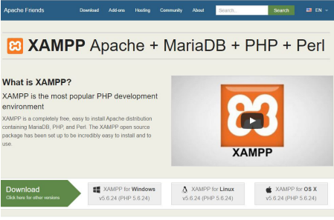Go to <https://www.apachefriends.org/> index.html and download the latest xampp installer with the latest PHP version. We impose to install xampp installer with PHP version 5.6 or higher because the software includes packages that require higher PHP requirement to run. Please do install this version or some features may not work. Follow the installation wizard to install.

Follow the installation wizard to install.

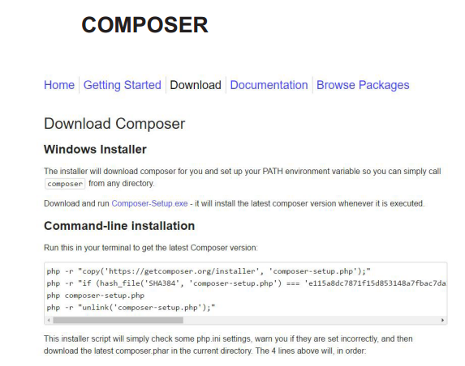

Go to getcomposer.org/download/and download windows installer if your using Windows platform and if you are using other platform kindly follow the installation process for the intended platform in the getcomposer.org website or ask any assistance for the installation. This is a critical process because the software will not run if this is not installed.

Please be guided that you need the apache server installed first because installation wizard will look for PHP path folder from apache server upon installation.

**MySQL Database**

Apache server have MySQL Database support already and you don't need other installation to install MySQL Database. You can access your database upon running the MySQL Service and APACHE service from XAMPP Control Center and open the link localhost/phpmyadmin to a browser.

**e-brgy SOFTWARE**

Copy the ZIP file from the installation DVD provided by the developer to the Apache folder that can be hosted. C:xampp/htdocs is the default path for XAMPP and C:wampp/www for wampp.

After copying the file, extract the files from the zip file using any zip extractor application or you can use the application default in Windows 10 to extract it. You will now then see the e-brgy folder. If the e-brgy folder contains the e-brgy folder inside then move the folder inside, outside the folder then the path should be

**Internet Implementation**

**SEARCH FOR HOSTING SERVICE**

Search for hosting service that supports LARAVEL php framework. If the hosting service supports LARAVEL php framework, it is now easy for you, you just have to upload the zip file from the DVD provided and it will automatically extract the file for you. If the hosting service do not support Laravel php framework, you need to upload the file 1 by 1. Make sure to upload all the files from the zip file or there will be a possibility for the application to not run. You are going to set up also the database from the hosting. Import the **db_ebrgy.sql** from the MySQL Database of the hosting service.

**CHAPTER III**

**SOFTWARE SETUP**

**Intranet Implementation**

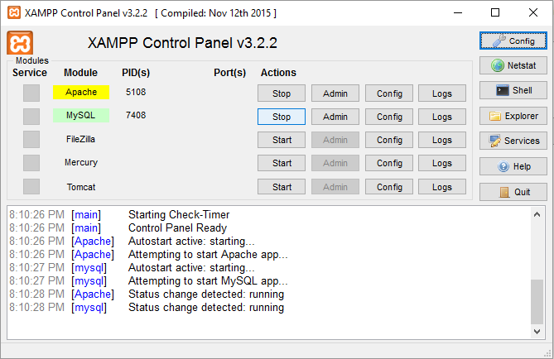**Running the server**

1. Run the XAMPP Control Panel and click run on the following service: Apache and MySQL.

**Internet Implementation**

The hosting service you chose will be providing a link where you will be accessing the Software. This link is the typical Unified Resource Link (URL) we are using to access different websites or social media.

**Chapter IV**

**SOFTWARE BASICS**

**Start-up Procedure**

1. Open the browser and type the link of provided by the hosting service. In case of intranet, use the ip address before together with the port number given by the php arti­san serve command earlier.

Example link: http://192.168.1.6:8000/public

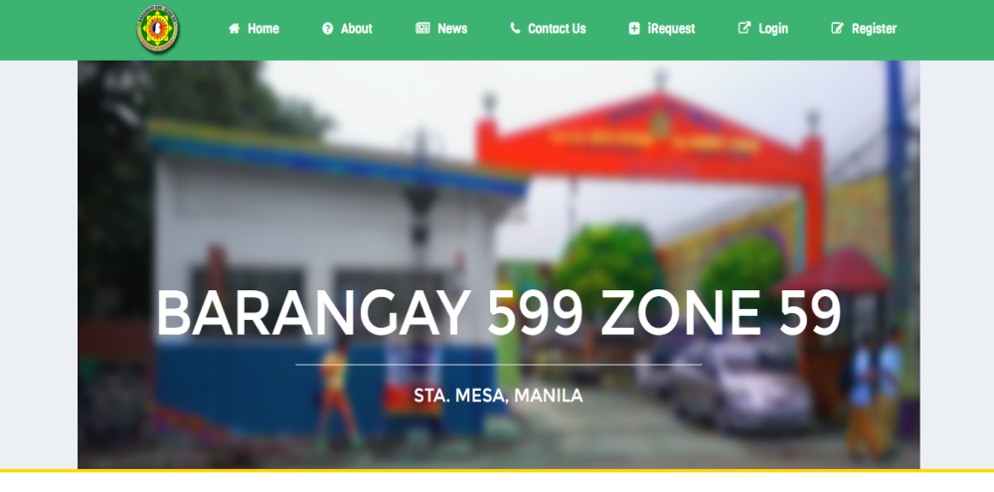Note: 8000 is the port number and /dash­board is the path you want to look first

1. Once you typed in the link. You will be directed to the website and click the “Login” in the navigation tab, found on the upper-right side of the website then login your account.

If you don’t have an account yet, you can click “Register” then input the needed information.

**NOTE:** Only a registered resident and elected officer within the barangay can register and have an account.

1. After you have successfully logged in, you will be directed to the dashboard.
2. 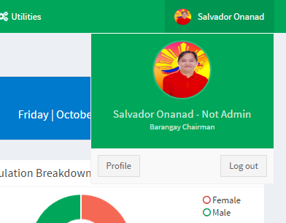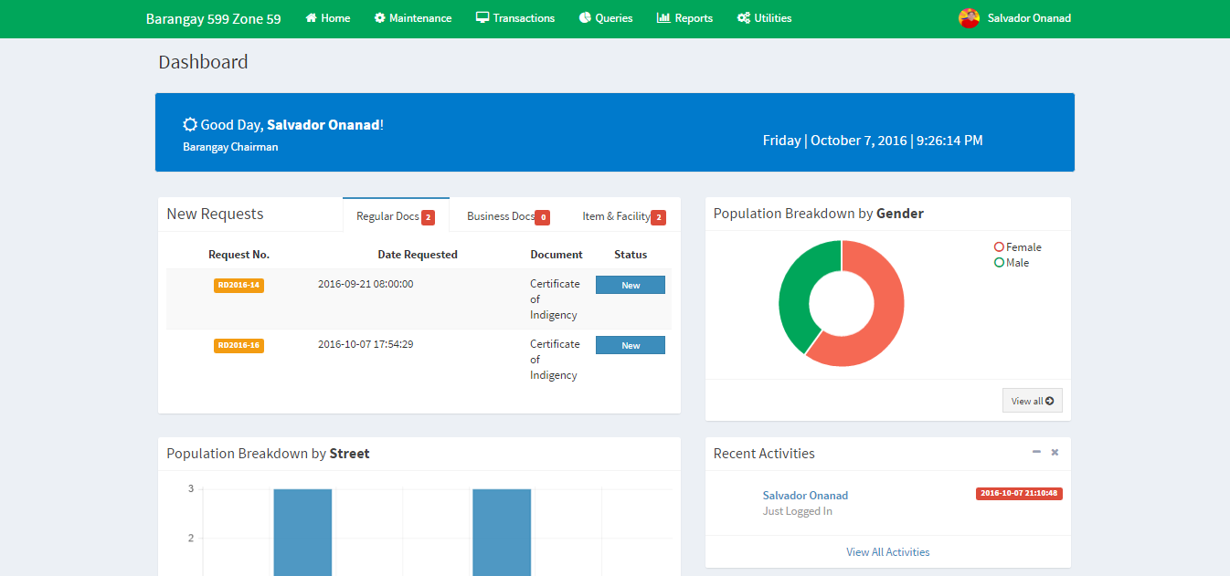To customize your profile picture and your signature, go to **Profile** by clicking the name displayed on the upper-right corner where you can also find the **Log out** button.
3. 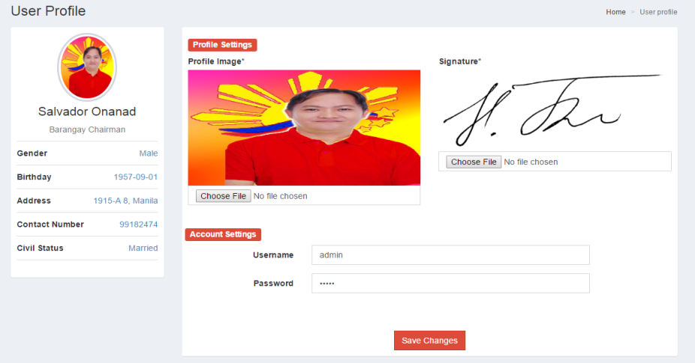In the profile section, it is ***important that you upload a picture format of your signature*.** Then click the **Save Changes** button.
4. You can change your Username and Password. Then click the **Save Changes** button.

**Chapter V**

**USING THE SOFTWARE**

**MAINTENANCE**

**Household Maintenance**

* This is where the user will input the details about a household.

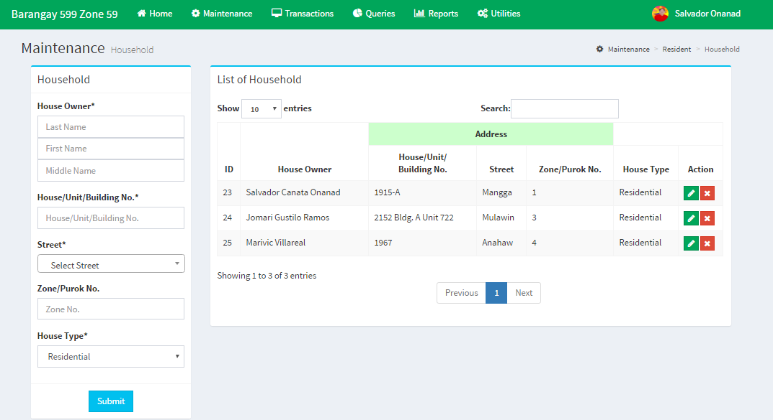

1. Input all the needed information on the left side of the form. Be sure to input all the right details. Then click “**Submit**” button below.
2. C:\Users\Asus\Desktop\Printscreen\Icons\Edit.PNG***Editing a saved household data,*** is to click the icon.
3. C:\Users\Asus\Desktop\Printscreen\Icons\Delete.PNG***Deleting a saved household data,*** is to click the icon.

**Resident Maintenance**

* 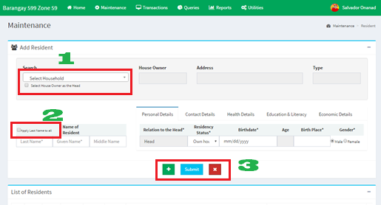This is where the user will input the details about every resident living in a household.

1. **C:\Users\Asus\Desktop\Printscreen\Icons\owner as head.PNG**Select Household where the residents will live.

Is use to Select the House Owner as the Head.

1. C:\Users\Asus\Desktop\Printscreen\Icons\ln to all.PNG is use so that the user will not retype the same surname.
2. C:\Users\Asus\Desktop\Printscreen\Icons\add.PNG***Adding a resident in a household.*** Click the icon to add another resident information.
3. C:\Users\Asus\Desktop\Printscreen\Icons\Delete.PNG***Removing a Field.*** By clicking the icon can remove the excess field/textboxes you added.
4. Click the **Submit** button to save the inputted information.

**Official Maintenance**

***Official Position***

* this is where the user will input the Official Position name and its quantity.

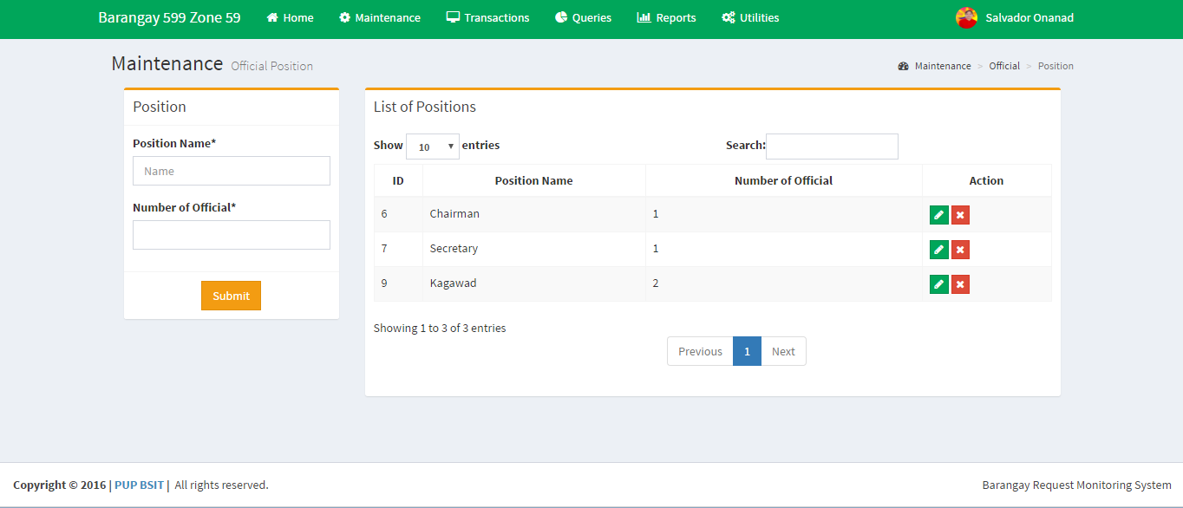

1. Input all the needed information on the left side of the form. Be sure to input all the right details. Then click “**Submit**” button below.
2. C:\Users\Asus\Desktop\Printscreen\Icons\Edit.PNG***Editing a saved Position data,*** is to click the icon.
3. C:\Users\Asus\Desktop\Printscreen\Icons\Delete.PNG***Deleting a saved Position data,*** is to click the icon.

***Official Details***

* This is where the user will identify the Barangay Official and the detail of his/her term.

**NOTE:** Only the registered resident in the barangay can be identify as an Official.

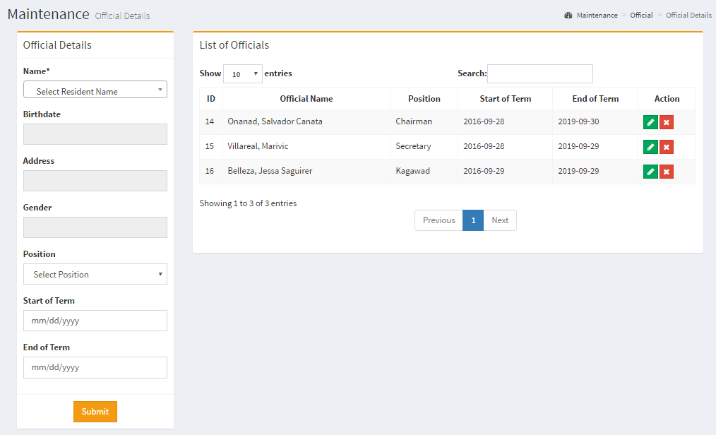

1. Input all the needed information on the left side of the form. Be sure to input all the right details. Then click “**Submit**” button below.
2. C:\Users\Asus\Desktop\Printscreen\Icons\Edit.PNG***Editing Position,*** is to click the icon.
3. C:\Users\Asus\Desktop\Printscreen\Icons\Delete.PNG***Deleting Position,*** is to click the icon.

**Business Maintenance**

***Business Type***

* This is where the type of business within the barangay is defined.

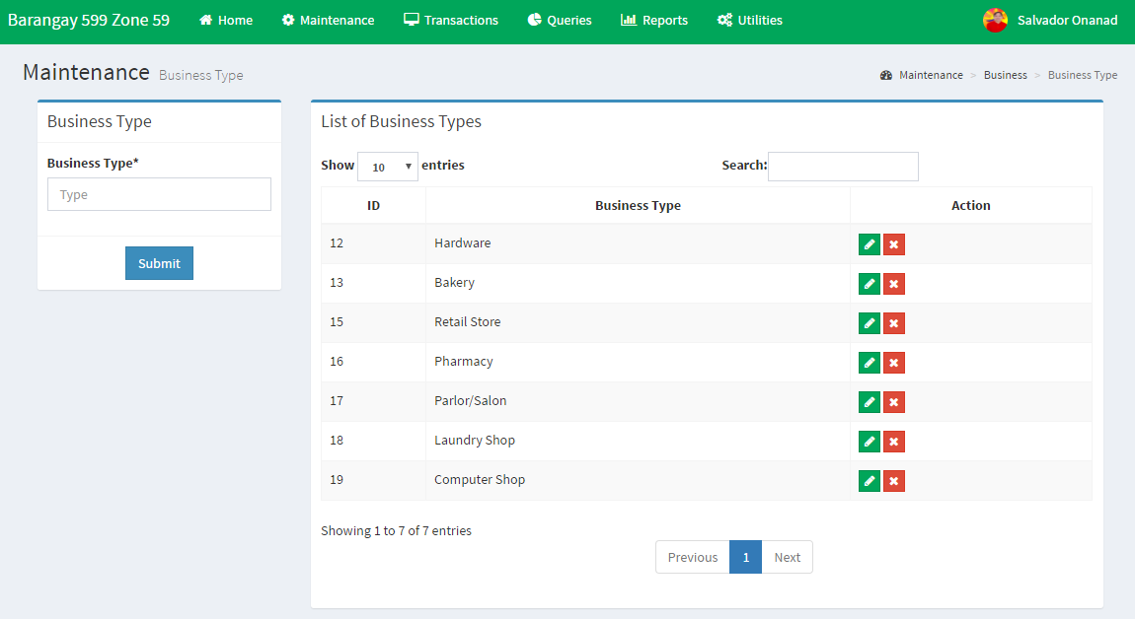

1. Input the business type on the left side of the form. Then click “**Submit**” button below.
2. C:\Users\Asus\Desktop\Printscreen\Icons\Edit.PNG***Editing Business Type,*** is to click the icon.
3. C:\Users\Asus\Desktop\Printscreen\Icons\Delete.PNG***Deleting Business Type,*** is to click the icon.

***Business Details***

* This is where all the transactions made for a business document is recorded or viewed. 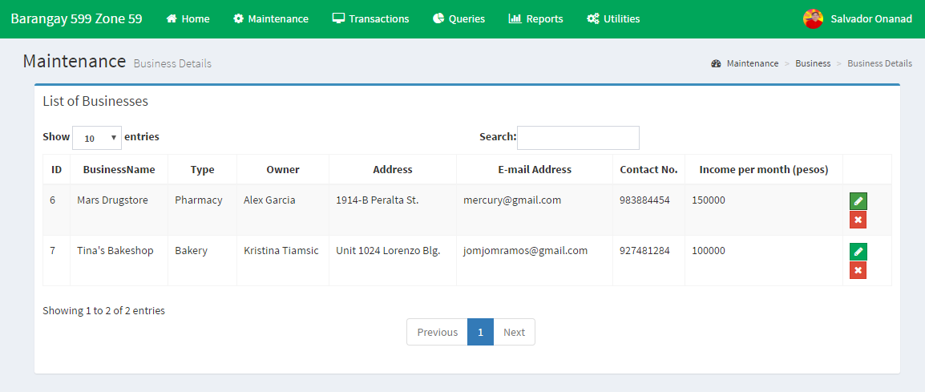

1. C:\Users\Asus\Desktop\Printscreen\Icons\Edit.PNG***Editing Business Details,*** is to click the icon.
2. C:\Users\Asus\Desktop\Printscreen\Icons\Delete.PNG***Deleting Business Details,*** is to click the icon.

**Facility Maintenance**

***Facility Details***

*This is where a facility within the barangay is defined.

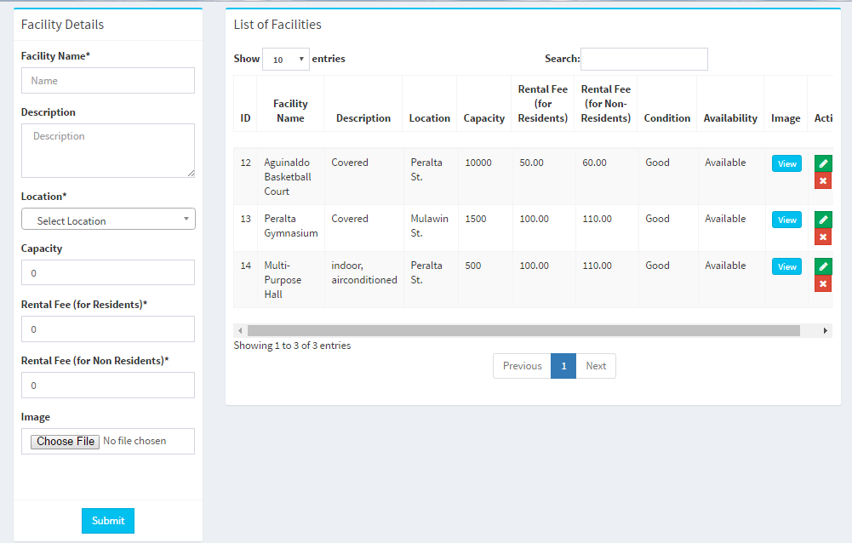

1. Input all the needed information on the left side of the form. Be sure to input all the right details. Then click “**Submit**” button below.
2. C:\Users\Asus\Desktop\Printscreen\Icons\Edit.PNG***Editing a Facility Detail,*** is to click the icon.
3. C:\Users\Asus\Desktop\Printscreen\Icons\Delete.PNG***Deleting a Facility Detail,*** is to click the icon.
4. C:\Users\Asus\Desktop\Printscreen\Icons\view image.PNG ***Viewing the Image of the Facility*** is by clicking the icon.

***Consuming Devices***

* This is where all the consuming devices found in a facility are added.

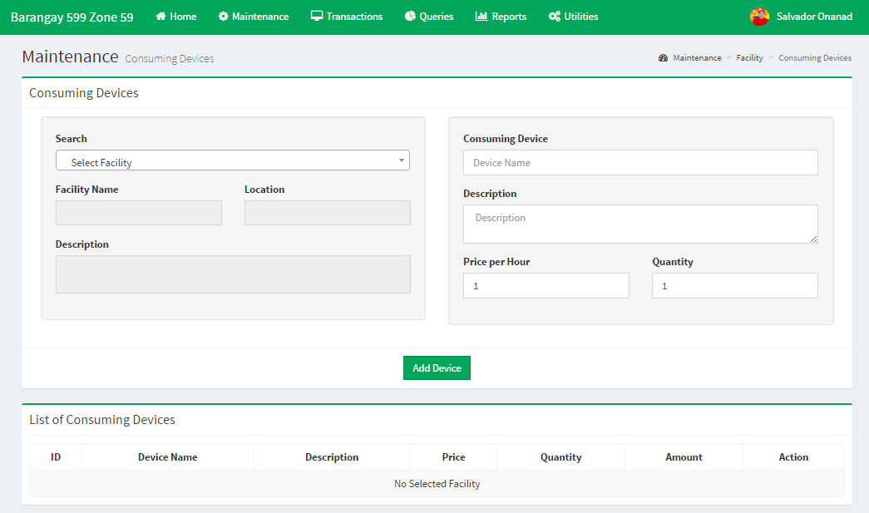

1. Select first the facility you want to add on a device.

**NOTE:** You can view the corresponding saved device on a facility after choosing a facility name.

1. Input the device name and its corresponding details asked in the form.
2. Then click the **Add Device button** to save.

**Item Maintenance**

***Item Details***

* This is where you input all the items that can be requested in the barangay.

1. C:\Users\Asus\Desktop\Printscreen\Icons\Edit.PNGInput all the needed information on the left side of the form. Be sure to input all the right details. Then click “**Submit**” button below.
2. ***Editing an Item Detail,*** is to click the icon.
3. 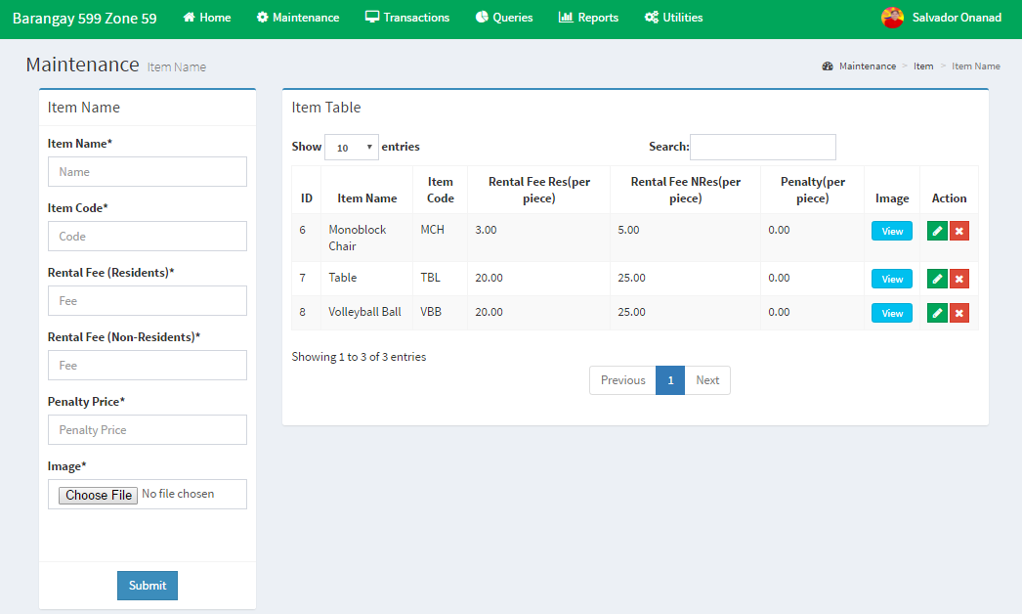C:\Users\Asus\Desktop\Printscreen\Icons\Delete.PNG***Deleting an Item Detail,*** is to click the icon.
4. C:\Users\Asus\Desktop\Printscreen\Icons\view image.PNG ***Viewing the Image of the Facility*** is by clicking the icon.

***Item Quantity***

* 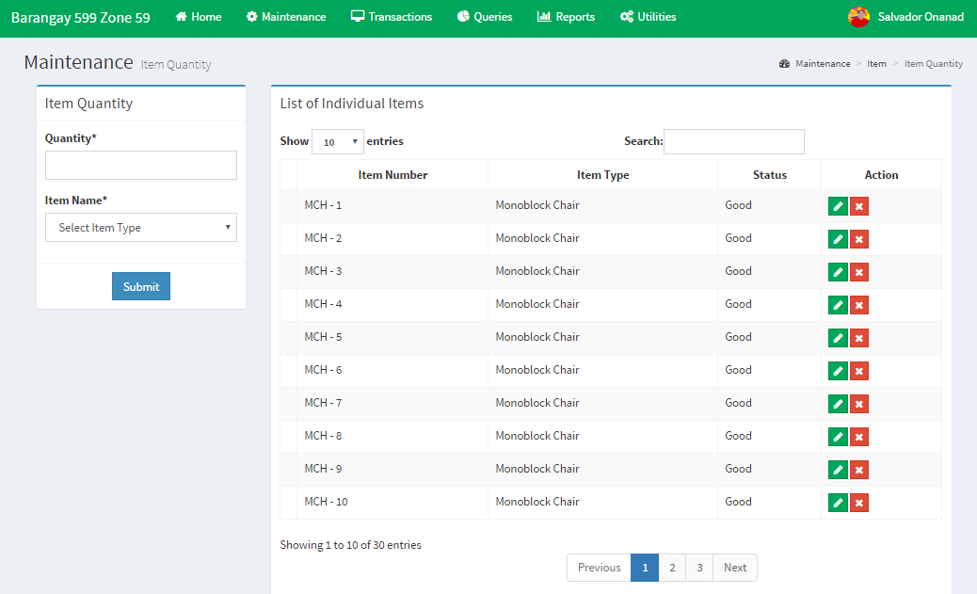This is where the user can input the quantity of an item that the barangay has.

1. Select an item type first then input the quantity. Then click “**Submit**” button below.

**NOTE:** The quantity inputted on the left side is viewed on the table where each item can be determined by their ‘Item Number’.

C:\Users\Asus\Desktop\Printscreen\Icons\Edit.PNG

1. ***Editing an Item Number,*** is to click the icon.
2. C:\Users\Asus\Desktop\Printscreen\Icons\Delete.PNG***Deleting an Item Number,*** is to click the icon.

**Document Maintenance**

***Document Layout***

* This is where the layout of a document is defined.

1. 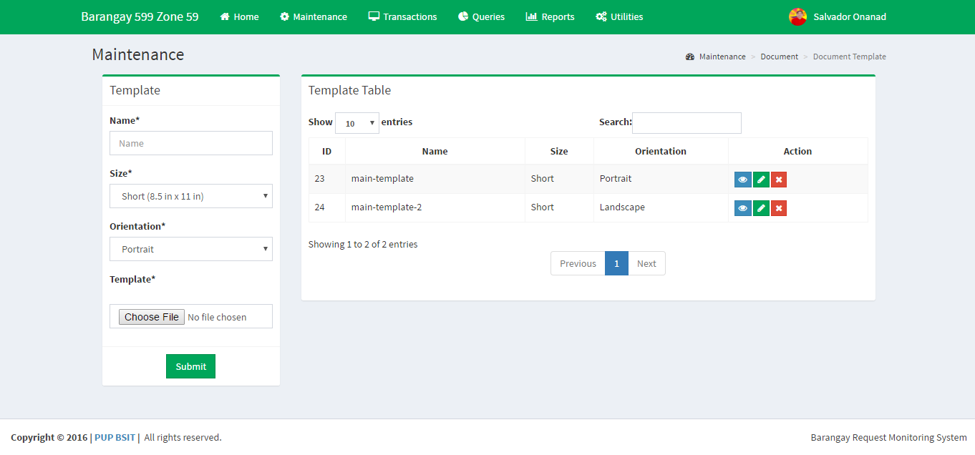Input all the needed information on the left side of the form. Be sure to input all the right details. Then click “**Submit**” button below.
2. C:\Users\Asus\Desktop\Printscreen\Icons\Edit.PNG***Editing a Facility Detail,*** is to click the icon.
3. C:\Users\Asus\Desktop\Printscreen\Icons\Delete.PNG***Deleting a Facility Detail,*** is to click the icon.
4. C:\Users\Asus\Desktop\Printscreen\Icons\View.PNG ***Viewing the Image of the Facility*** is by clicking the icon.

***Document Template***

* This is where the user customize the content and design of the chosen template or layout.

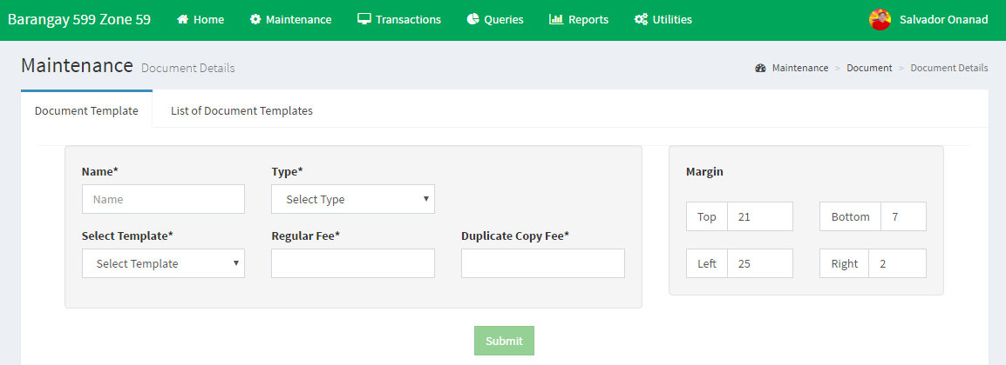

1. Input the details about the document template. Select the *Document Layout.*
2. Customize margin of the document
3. 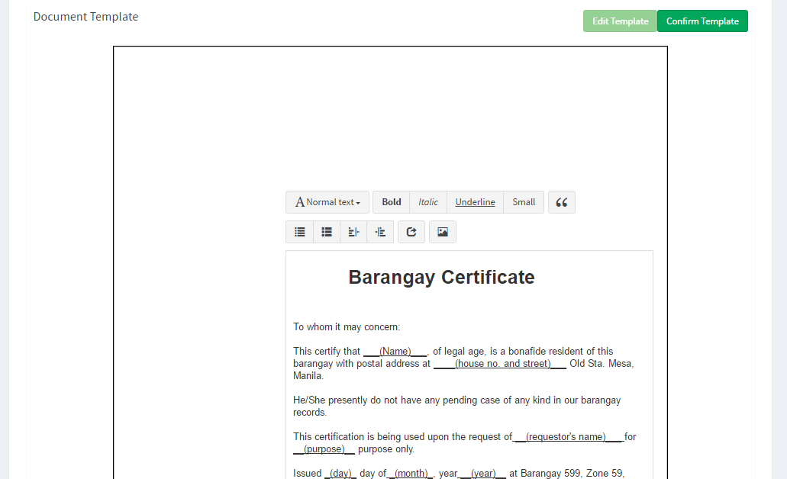Be sure that **Edit Template** is clicked to customize the content of the document.
4. After inputting the content click **Confirm Template.**
5. If you are sure about the content and layout of the document click the **Submit** button.

**TRANSACTION**

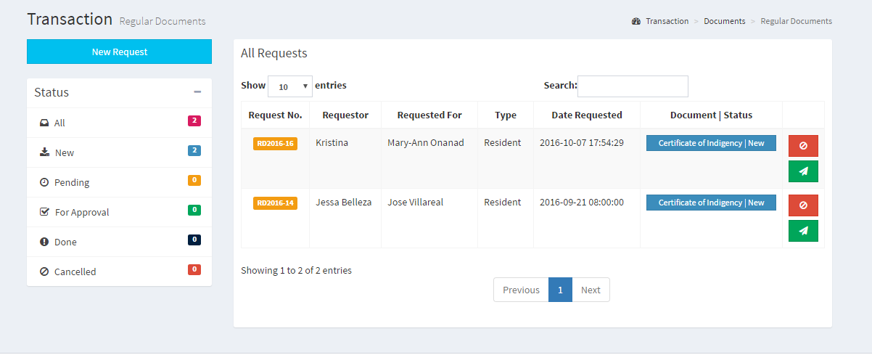**Regular and Business Document**

***Figure 1:*** *All Requests Table*

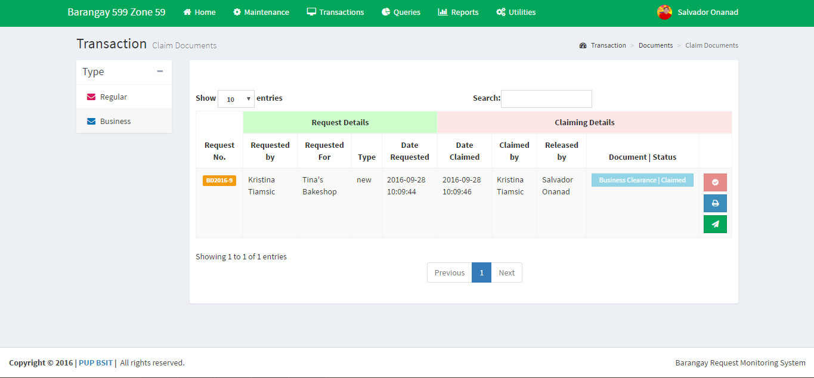***Figure 2:*** *Claim Documents*

***Requesting of Document***

1. Click the ***New Request*** button. *See Figure 1*.
2. Choose whether the requestor of *Regular Document* is ***Resident*** or ***Non-Resident***. **NOTE:** Not all documents in the barangay are available for ***Non-Residents.***

For *Business Document,* choose whether the requestor asked for a ***New*** or ***Renew*** of document.

1. 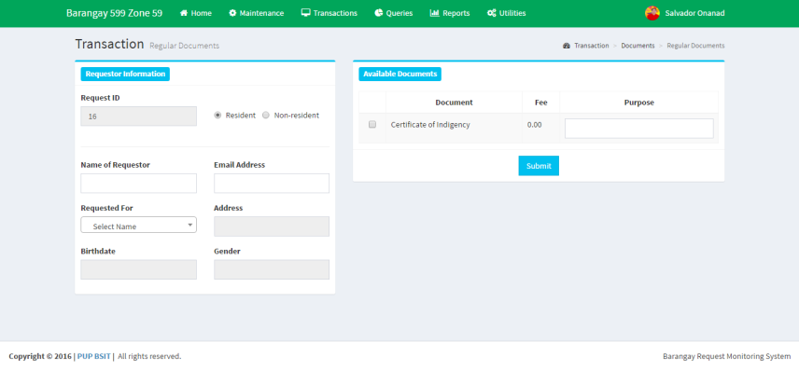Fill-up the needed information. (All Fields are Required)
2. Choose the Document that the client wants to request. **NOTE:** the client can request more than one document.
3. 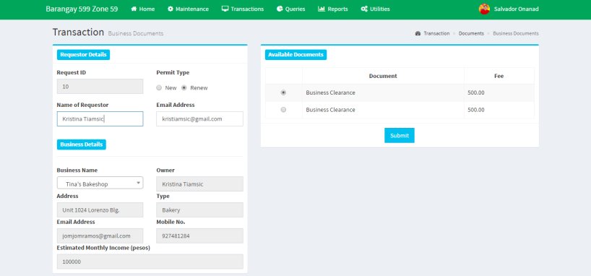Click **Submit** button.

***Approval of Documents (****See Figure 1****)***

**NOTE:** Officials can only approve a specific document status depending on their Position set in the User Privileges (Utilities).

C:\Users\Asus\Desktop\Printscreen\Icons\send.PNG**NOTE:**  Updating the requestor of the status of their document can be done by clicking the icon.

1. ***C:\Users\Asus\Desktop\Printscreen\Icons\New.PNG*** is a status that can be access by Kagawad.
2. ***C:\Users\Asus\Desktop\Printscreen\Icons\Pending.PNG*** is a status that can be access by Secretary.
3. ***C:\Users\Asus\Desktop\Printscreen\Icons\Approval.PNG*** is a status that can be access by the Chairman.

***Printing of Document (****See Figure 2****)***

1. C:\Users\Asus\Desktop\Printscreen\Icons\Print.PNGClick the icon. A pop-up will come out to view the document that will be printed.
2. Click the **Download** button for you to be able to print the requested document.
3. After the file has been downloaded make sure to click the **Submit** button to change the status to ***Printed.***

**NOTE:** A document can only be printed once.

***Claiming of Document (****See Figure 2****)***C:\Users\Asus\Desktop\Printscreen\Icons\Claimed (2).PNG

1. Click the icon. A pop-up will come out to view the document that will be claimed.
2. Click the **Submit** button to change the status to ***Claimed***

***Payment of Document***

1. C:\Users\Asus\Desktop\Printscreen\Icons\Unpaid.PNGClick the icon shown in *Figure 3*. You will be directed to the **Payment section** (*See Figure 4*).
2. In the Payment Section, input the name of who paid for the document and choose the **Payment Type**. If the Payment Type is waived means the document is free.
3. Click the **Print** button to print the receipt.
4. C:\Users\Asus\Desktop\Printscreen\Icons\Paid.PNGThen click submit to update the status to **(Paid )**

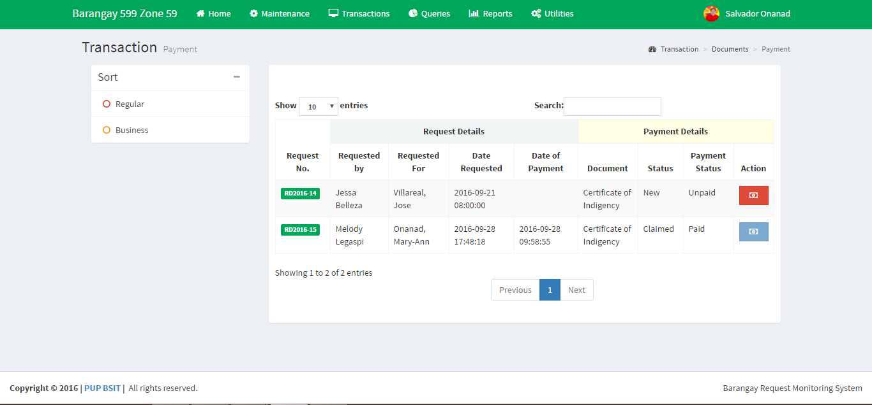

***Figure 3:*** *Payment Table*

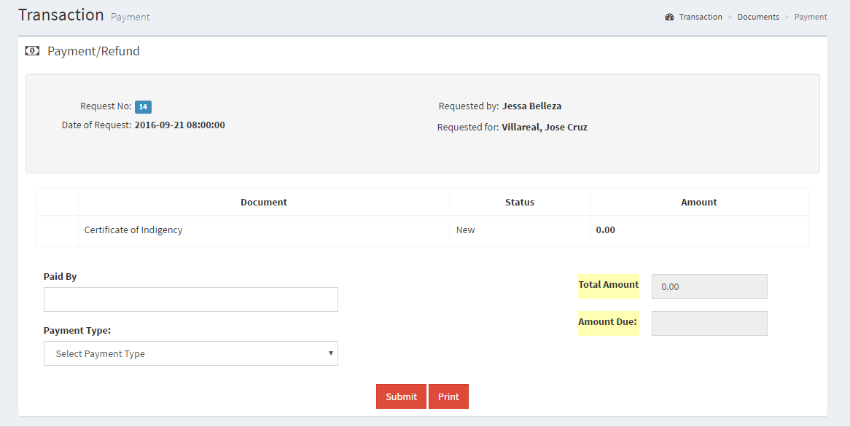

***Figure 4:*** *Payment Section*

**Item and Facility Request**

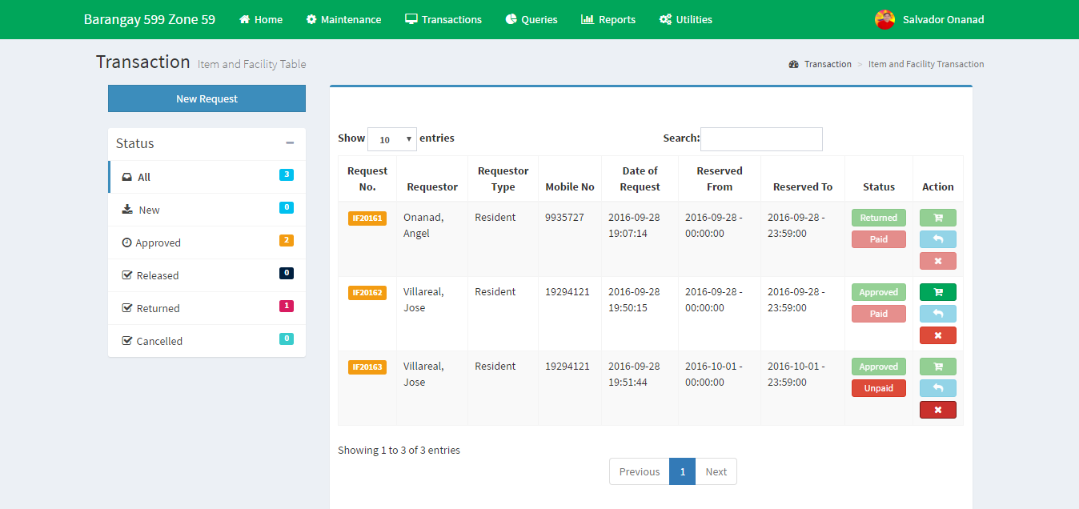

***Figure5:****Requested Items and Facilities*

***Requesting of Item and Facility***

1. Click the **New Request** button. (*See Figure 5*)
2. 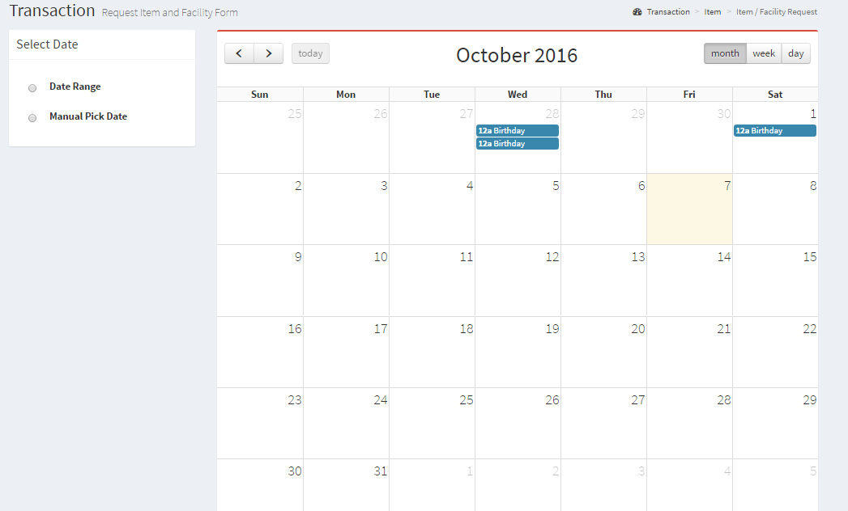Choose on the left side on how you want to reserve the date. ***Date Range:*** you will click the the date and choose the time you want to reserve an item or facility.

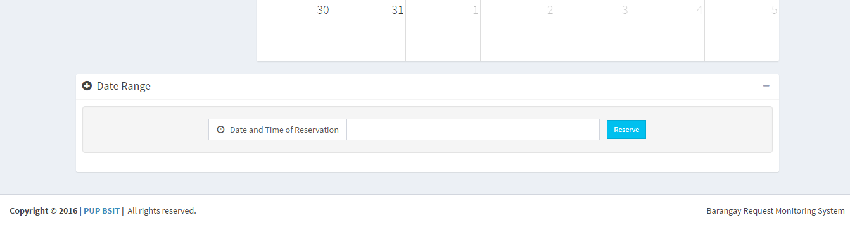***Manual Pick Date:*** You will type the date and time you to reserve an item or a facility.

1. 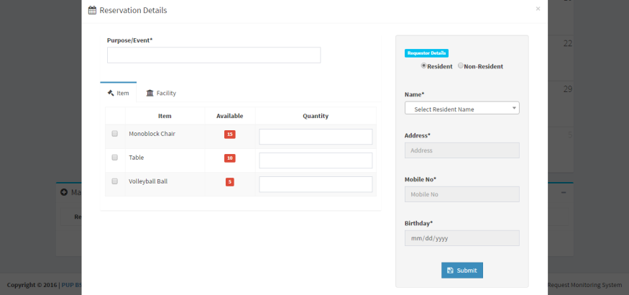After choosing the date range of your reservation, click the button **Reserve.**
2. A pop-up will appear. Input **all** the needed information. Click the radio button of the item or facility you want to reserve and the quantity.
3. Click the **Submit** button below the *Requestor Details.*

C:\Users\Asus\Desktop\Printscreen\Icons\Issue Request.PNG***Issuing of Item and Facility***

1. Click the icon for issuing the requested items and facilities. (*See Figure 5*)
2. You will be directed to the issuing of items and facilities where you can check and edit the request you have made. (*See Figure 6*)
3. Click the **Submit** button if you are content with the reservation.
4. A confirmation box will appear to view the summary of the reservation you made. (*See Figure 7*)
5. Click the **Confirm** button to issue the items or facility requested.

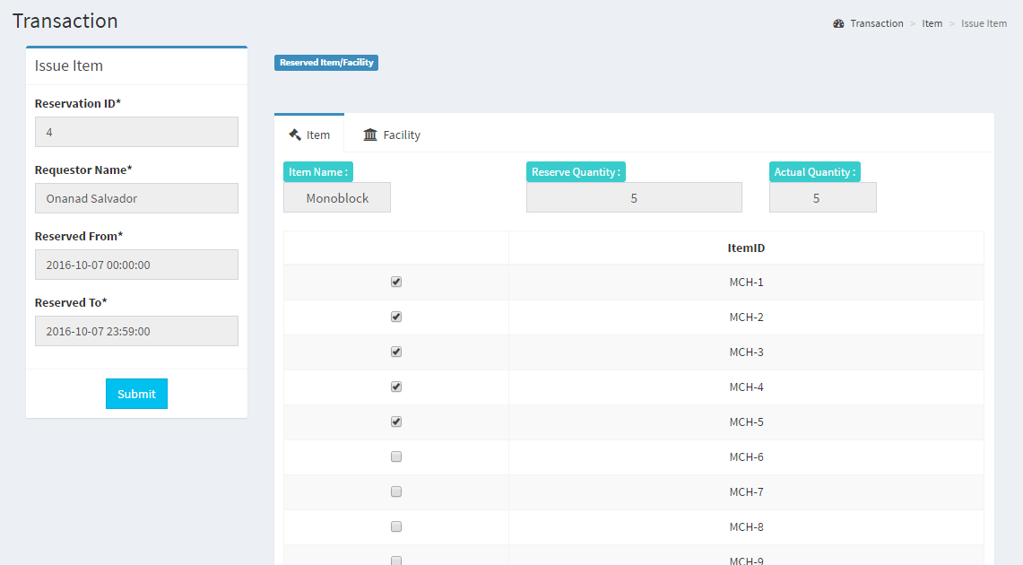***Figure 6:*** *Issuing Items and Facilities*

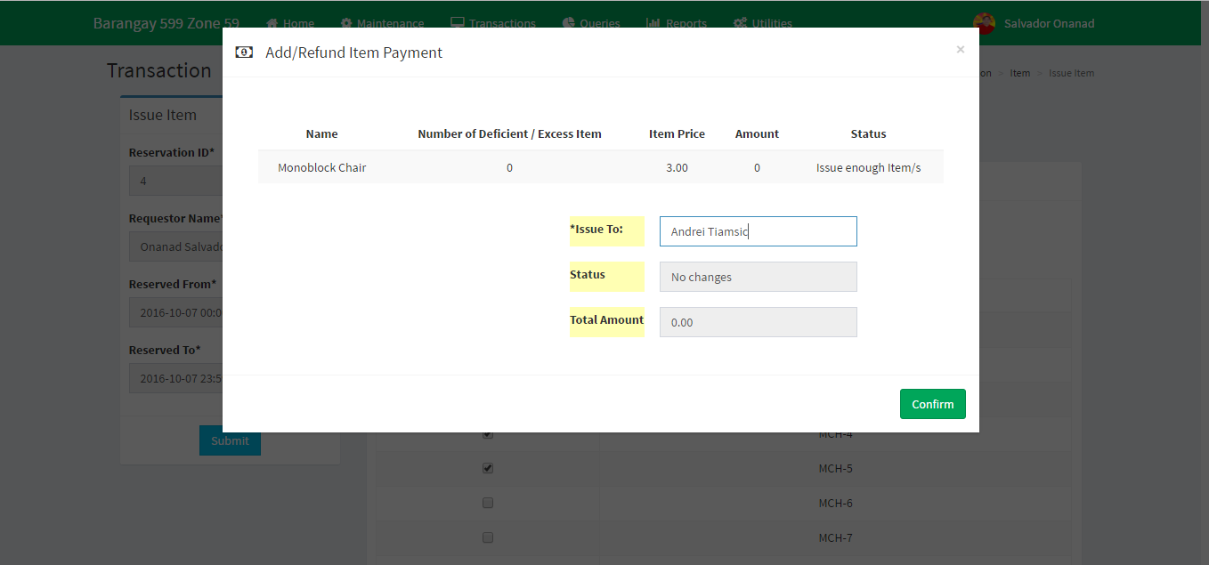 ***Figure 7 :*** *Confirmation for issuing the request*

C:\Users\Asus\Desktop\Printscreen\Icons\return items faci.PNG***Returning of Item and Facility***

1. Click the icon to return requested items or facilities.
2. You will be directed to the return section of reservation. (*See Figure 8*)
3. Click the Item Name or Facility Name.
4. Change the status of each item if it was broken, damaged or missing after the return.
5. After identifying the status of the requested item or facility. Click the **Submit** button to confirm the returning of request.

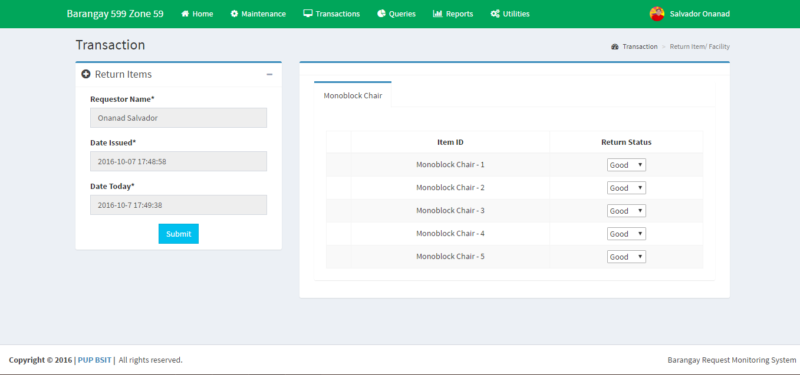

***Figure 8:*** *Return Items or Facility*

***Payment of Request***

1. If you are on *Figure 5.*

***C:\Users\Asus\Desktop\Printscreen\Icons\unpaid=payment.PNG***Click the icon. You will be directed to the Payment Section. (*See Figure 10*)

1. C:\Users\Asus\Desktop\Printscreen\Icons\Unpaid.PNGAnother way to record payment is to go to Transaction tab, under the Item and Facility panel, click *Payment***.** You will be directed to *Figure 9.*

Click the icon*.* You will be directed to the Payment Section. (*See Figure 10*)

1. Input and select the necessary data for payment.
2. Click the **Submit** button to confirm payment
3. C:\Users\Asus\Desktop\Printscreen\Icons\Download Payment Summary.PNGYou can *download and printthe Payment Summary* of a reservation by clicking the icon.

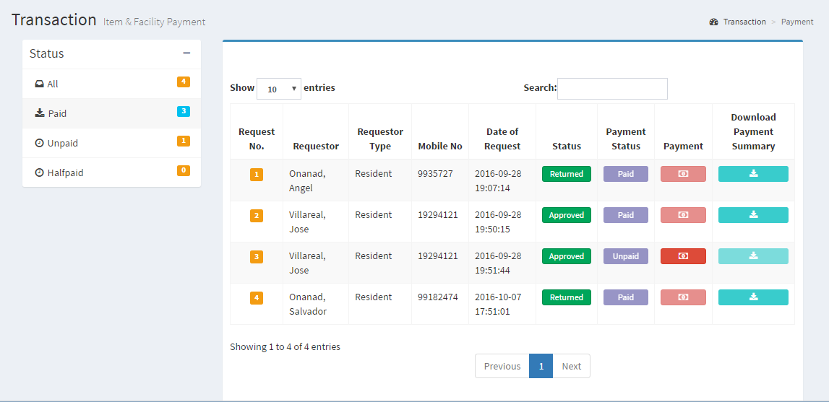

***Figure 9:*** *Item and Facility Payment*

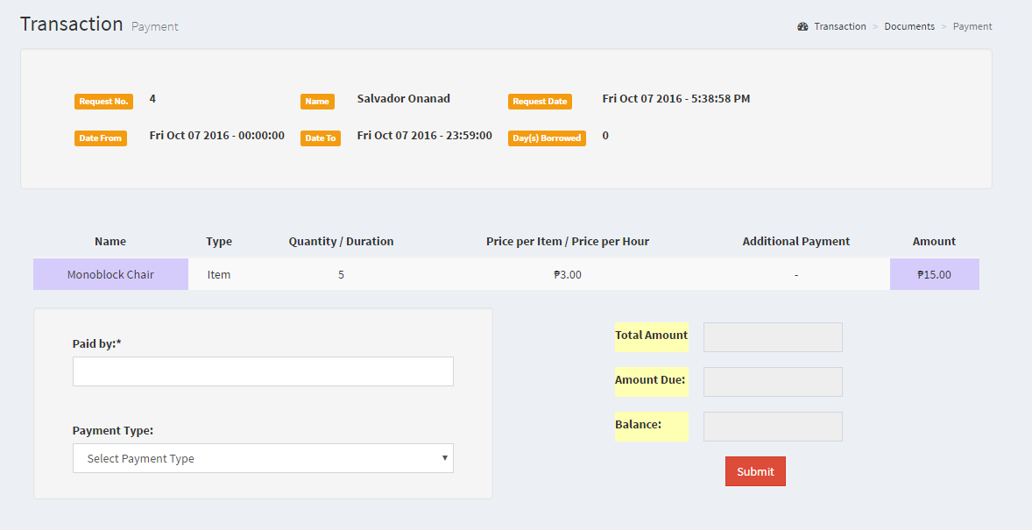

***Figure 10:*** *Payment Section for Requesting of Item and Facility*

**Manage Resident**

* Click the **View Family** button, you will be directed to *Figure 12* where you can add, edit and delete resident or deactivate a household.

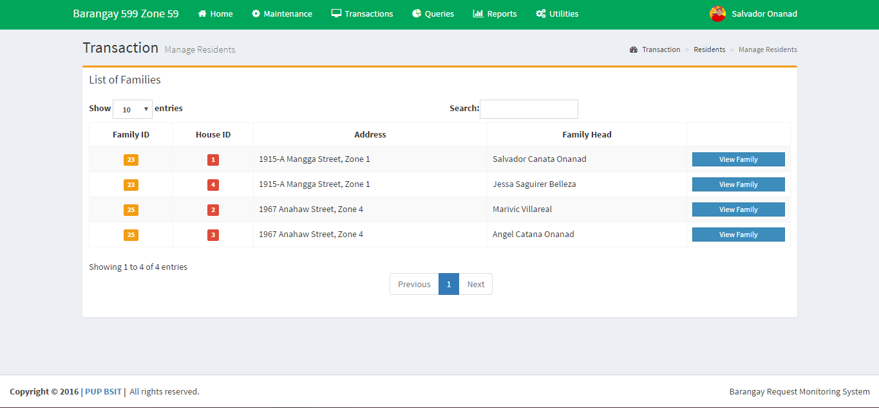

***Figure 11:*** *List of Household and Family Head.*

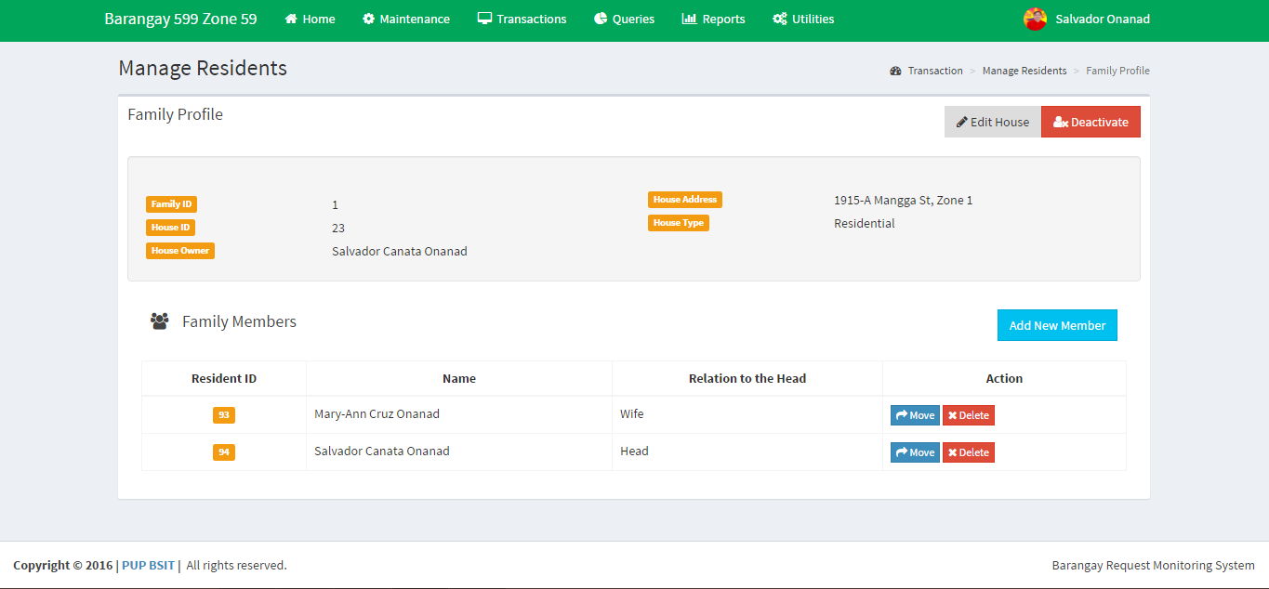

***Figure 12:*** *Manage Residents*

***Moving of Family to another house within the Barangay***

1. Click the **Edit House** buttonfound on the upper-right corner of the form (*Figure 12)*.
2. Select the Household address where the family will move to.
3. Click **Save** to confirm the move-in of the Family to that household.

***Moving of Family to another house outside the Barangay (Deactivated)***

1. Click the **Deactivate** buttonfound on the upper-right corner of the form (*Figure 12)*.
2. Click the **Delete** button to confirm deactivation of the family that lived in the barangay.

***Adding New Member of the Household/Family***

1. Click the **Add New Member** buttonfound in the middle part of the form (*Figure 12)*.
2. Input all the required data about the resident then click the **Add Member** button to save the information.

C:\Users\Asus\Desktop\Printscreen\Icons\move.PNG***Moving of a Resident within the Barangay***

1. Click the icon.
2. Select if the Resident will move to different house as *New Member* or *As New Family(that person will automatically be the Head of that household)*
3. Input all the information needed.
4. If finish, click **Save** button.

***Deactivation of Resident***

C:\Users\Asus\Desktop\Printscreen\Icons\delte.PNG***\*Deactivation of a Resident is when that person is deceased or had been moved out of the household***

1. Click the icon.
2. Choose the Reason (Deceased or Moved out)
3. Click the **Save** button to deactivate.

**QUERIES**

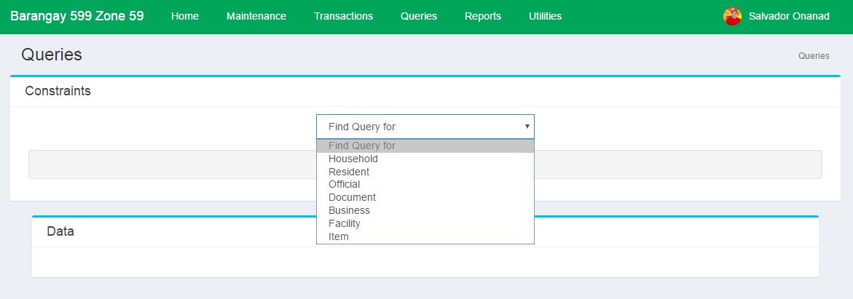

1. Select the module in Maintenance that you want to query.
2. Select the details you want to filter the information.
3. Click the **Refresh** button to view the data.

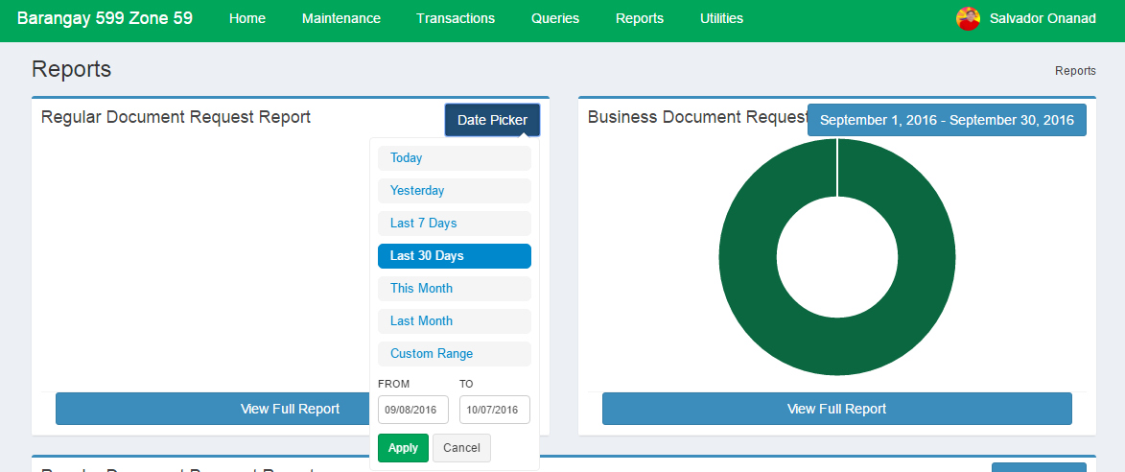**REPORTS**

1. Select or Input a Date Range.
2. Click the **View Full Report** to view and print the specific Report.

**UTILITIES**

**BARANGAY DETAILS**

**\***This is where the all the details of the barangay are set.

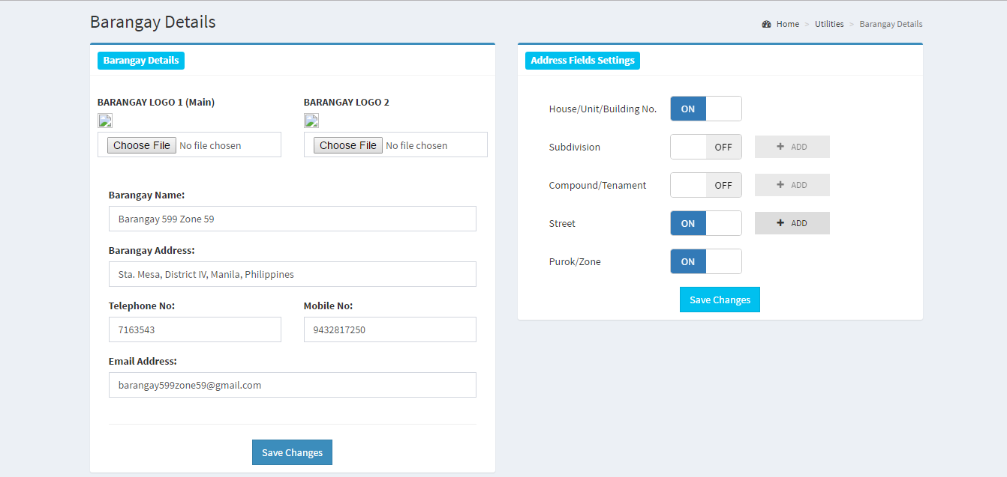**Barangay Details**

1. Choose and input the details asked.

2. Click the **Save Changes** button.

**Address Field Settings**

1. Activate the fields of an address that are needed.
2. If the fields Subdivision, Compound and Street are activated. Click the **Add** button to add the description. Click **Add** to save.
3. Click the **Save Changes** button to save all the data.

**USER PRIVILEGES**

**\***Give privilege to every user of the software by activating it. Then click the **Save** button when done.

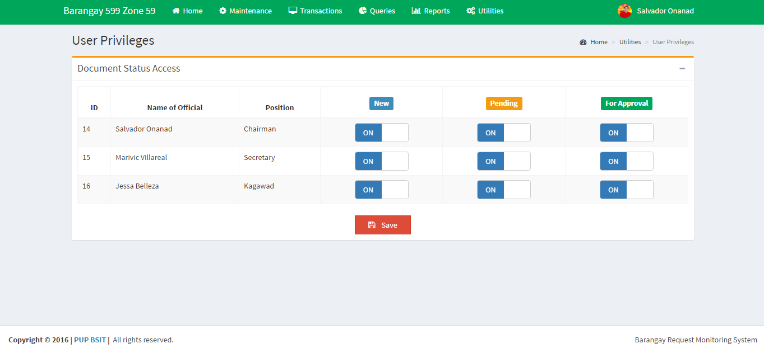**AUDIT TRAIL**

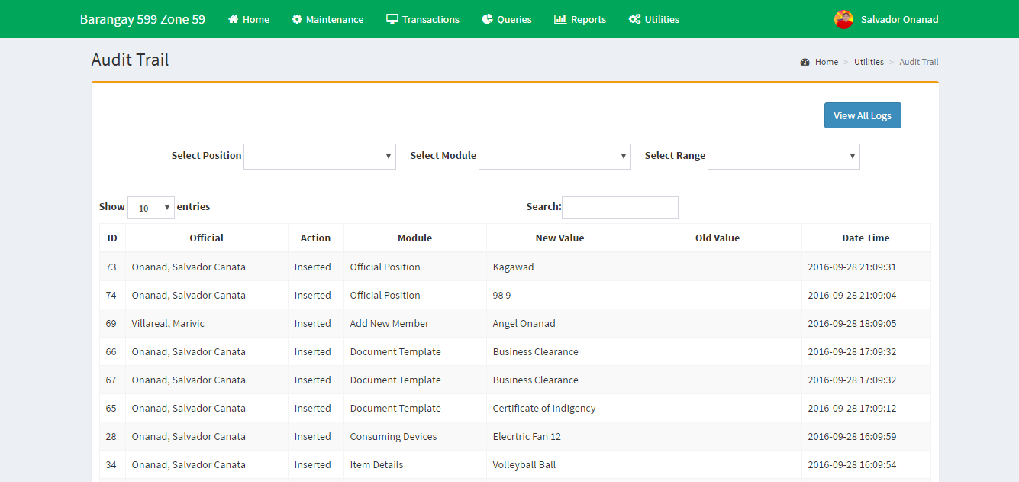**\***List of activities done in the system.

**CUSTOMIZE ADMIN PAGE**

*Changes the color or theme of the Admin/Official Account Page

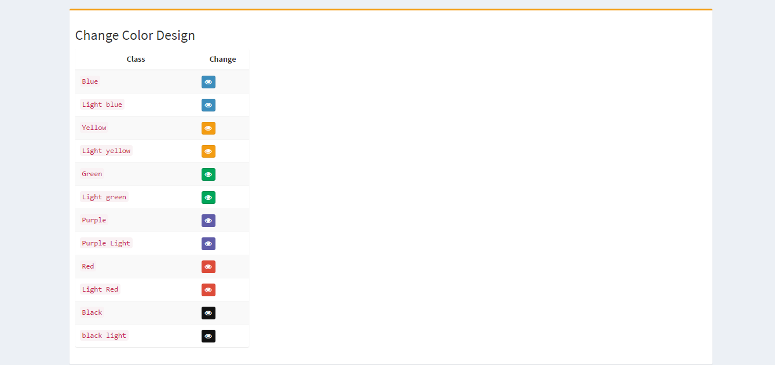

**CHAPTER VI**

**Basic Troubleshooting**

**Success Message**

If this message appears, it means changes have been saved. Green message means a successful transaction.



**Error Messages**

If error message like this appears, it means there is an error based on your inputs. Maybe, your inputs do not pass our validation. Kindly recheck your inputs before pressing the submit or saved button. If it happens in the log in page, you might have authentication error. That means that you enter the wrong credentials. If it happens to be complete in form but requires an image to be uploaded, then the image must be quite big or the file type or file extension of the image is not accepted by our validator. Try changing the image type or image file extension to the file extension that is required in the system and try to use smaller image in storage size. If it persists, call for assistance.

**Alert Messages**

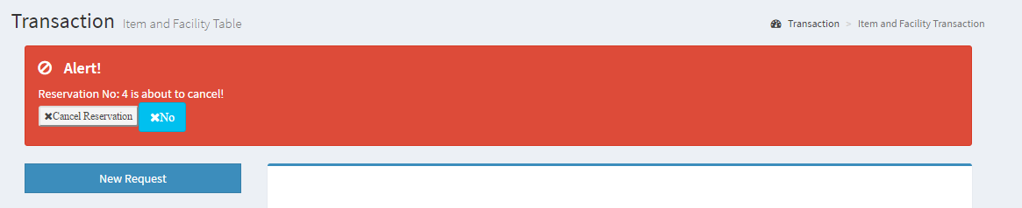

This Alert Message will appear in (*See Figure 8*) after every new request of an item and facility if the requestor wanted to cancel the reservation. Click **No** to remove the alert.



**Copyright 2016 by e-brgy Project Team**